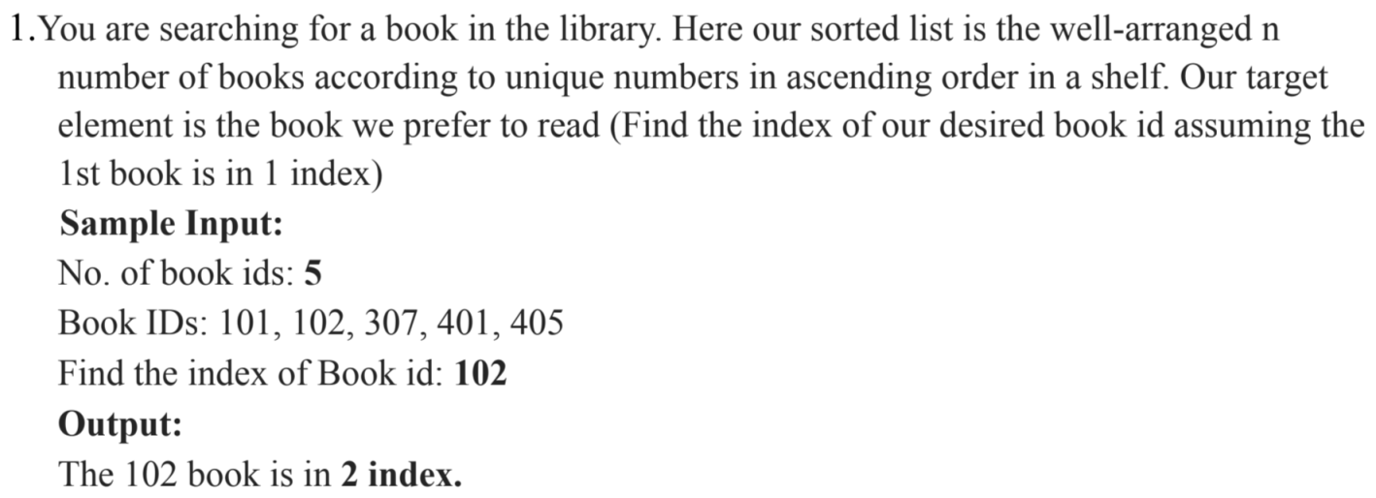

#include <stdio.h>

int binarySearch(int arr[], int n, int target)

{ int left = 1; // Start from index 1

int right = n;

while (left <= right)

{ int mid = left + (right - left) / 2;

if (arr[mid] == target)

return mid;

else if (arr[mid] < target)

left = mid + 1;

else

right = mid - 1; }

return -1; }

int main()

{ int n, target;

printf("No. of book IDs: ");

scanf("%d", &n);

int bookIDs[n + 1]; // Increase the array size by 1

printf("Book IDs: ");

for (int i = 1; i <= n; i++)

scanf("%d", &bookIDs[i]);

printf("Find the index of Book ID: ");

scanf("%d", &target);

int index = binarySearch(bookIDs, n, target);

if (index != -1)

printf("The %d book is in %d index.\n", target, index);

else

printf("The %d book is not found.\n", target);

return 0;}

**Output:** No. of book IDs: 5

Book IDs: 101

102

307

401

405

Find the index of Book ID: 102

The 102 book is in 2 index.

Process returned 0 (0x0) execution time : 21.481 s

Press any key to continue.

**1**

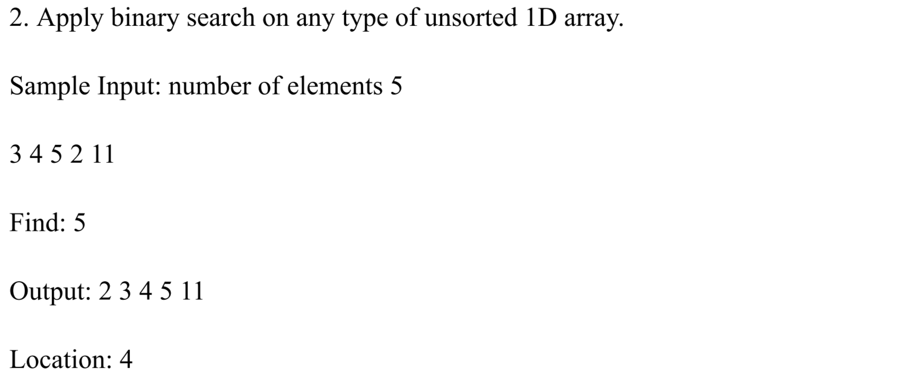

#include <stdio.h>

int binarySearch(int array[], int low, int high, int target) {

while (low <= high) {

int mid = low + (high - low) / 2;

if (array[mid] == target)

return mid;

else if (array[mid] < target)

low = mid + 1;

else

high = mid - 1;}

return -1;}// If the target is not found, return -1

int main() { int n;

printf("No. of elements: ");

scanf("%d", &n);

int array[n];

printf("Enter the elements:\n");

for (int i = 0; i < n; i++) {

scanf("%d", &array[i]); }// Sorting the array in ascending order (if it's not already sorted)

for (int i = 0; i < n - 1; i++) { // Fixed the loop termination condition

for (int j = 0; j < n - i - 1; j++) {

if (array[j] > array[j + 1]) {

int temp = array[j];

array[j] = array[j + 1];

array[j + 1] = temp; }}}

int target;

printf("Find the element: ");

scanf("%d", &target);

int result = binarySearch(array, 0, n - 1, target);

if (result != -1)

printf("The %d book is in index %d\n", target, result);

else

printf("Element not found in the array.\n");

return 0;}

**2**

**Output:** No. of elements: 5

Enter the elements:

3

4

5

2

11

Find the element: 5

The 5 book is in index 3

Process returned 0 (0x0) execution time : 23.918 s

Press any key to continue.

**3**

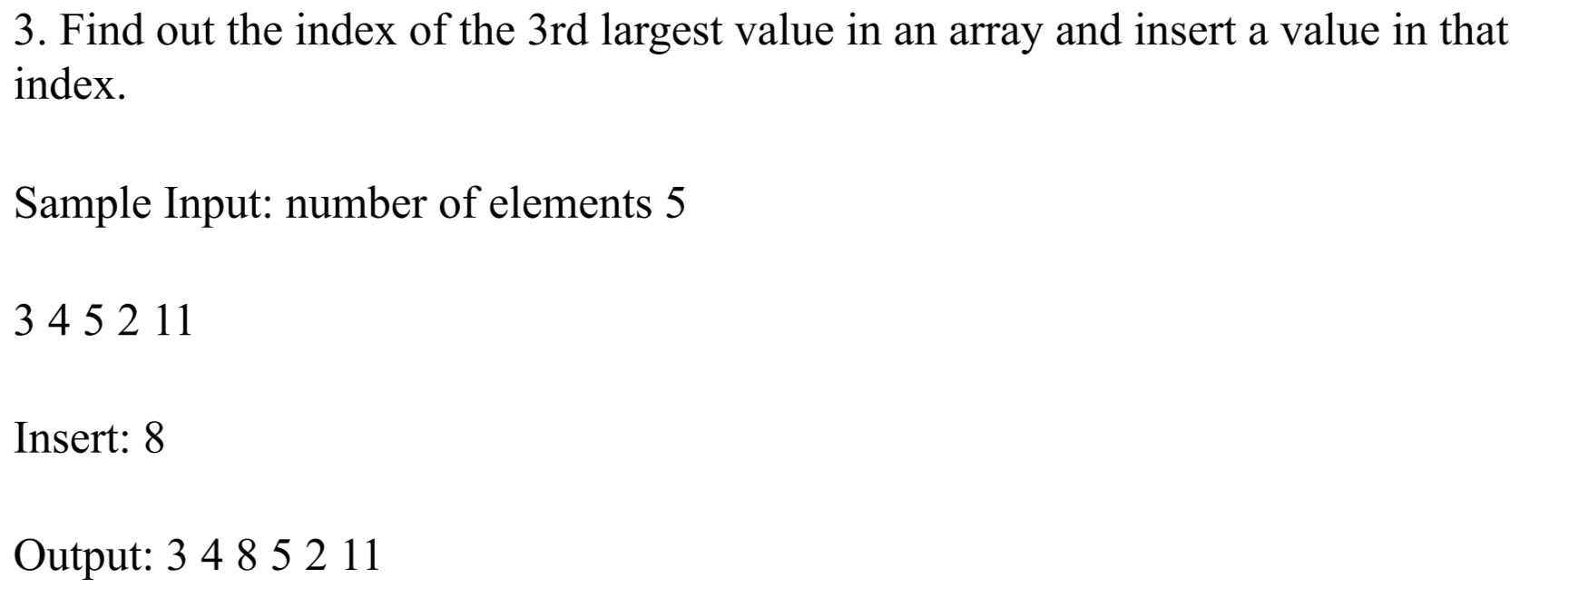

#include<stdio.h>

void main()

{ int n,i,num;

printf("Enter number of elements in the array :");

scanf("%d",&n);

int arr[n+1];

for (int i = 1; i <= n; i++)

{scanf("%d", &arr[i]);}

int firstLargest = 0;

int secondLargest = 0;

int thirdLargest = 0;

int firstLargestindex = 0;

int secondLargestindex = 0;

int thirdLargestindex = 0;

for (int i = 1; i <= n; i++)

{if (arr[i] > firstLargest)

{ thirdLargest = secondLargest;

secondLargest = firstLargest;

firstLargest = arr[i];

thirdLargestindex = secondLargestindex;

secondLargestindex = firstLargestindex;

firstLargestindex = i; }

else if (arr[i] > secondLargest)

{ thirdLargest = secondLargest;

secondLargest = arr[i];

thirdLargestindex = secondLargestindex;

secondLargestindex = i; }

else if (arr[i] > thirdLargest)

{ thirdLargest = arr[i];

thirdLargestindex = i; } }

printf("Enter the data you want to insert: ");

scanf("%d", &num);

for ( i = n; i >=thirdLargestindex; i--)

{ arr[i+1]=arr[i]; } n++;

arr[thirdLargestindex] = num;

printf("Output\n");

for ( i = 1; i <=n; i++)

{printf("%d ", arr[i]); }}

**4**

**Output:**

Enter number of elements in the array :5

3

4

5

2

11

Enter the data you want to insert: 8

Output

3 8 4 5 2 11

Process returned 6 (0x6) execution time : 12.557 s

Press any key to continue.

**5**